C372 CA2 AI Interaction Journal
Student ID | 24041908
Student Name | Deron Kwok
Class | E63C

Overview
In CA2, you will enable payments in the Supermarket App that you have worked on in CA1.

The AI Interaction Journal is designed to help you document, reflect on, and evaluate your use of generative AI tools (such as ChatGPT, Gemini, or Copilot) during the development of CA2 deliverable.

It promotes responsible and thoughtful use of AI, encouraging you to develop key skills in prompt design, critical evaluation of AI responses, and independent problem-solving.

This journal demonstrates how you used AI as a collaborative thinking partner—to explore ideas, test solutions, and deepen your understanding of code, rather than simply to produce answers.

In this journal:
- You will use this journal to record your key prompts, results, and reflections as evidence of how you engaged with AI responsibly throughout your project.
- You will need to identify the tasks related to the feature(s) you are building
- For each task, update the status, objective, goal(s), preparation work(s) for mentioned task, AI tool(s) used, entity table(s), relevant source code files, prompt(s) and results.

Note:
- Please read through the entire document before you begin.
- This AI Interaction Journal is part of CA2 Deliverable submission.
- Do not include personal information, passwords, API keys, or any confidential data. This log is for learning reflection and responsible AI use.

You may refer to C372 Individual Graded Assignment AI Interaction Journal – SAMPLE.docx for a reference on how to use this document.
Table of Contents
Overview 1
Enabling Payment Solution(s) in SupermarketAppMVC 3
Task Logs 4
Task 1 – Task 1 Name 4
OBJECTIVE 4
PROMPT(S) USED 4
AI RESPONSES/CODE GENERATED 4
RESULTS 4
Screenshots of the Payment Process Flow 5
Reflection on the use of GenAI for Enabling Payments 6

Note: Remember to update the table of contents for the latest updates to reflect above.

Enabling Payment Solution(s) in SupermarketAppMVC

- Identify the payment solution(s) you plan to implement in SupermarketAppMVC.
Based on the SupermarketAppMVC implementation, the application supports multiple online payment solutions to allow customers to complete purchases securely and conveniently. The payment solutions implemented in the system are:
- Firstly, Stripe Card Payments are implemented to allow customers to pay using debit or credit cards. Stripe is used as the payment gateway to securely handle card details and process transactions without exposing sensitive information to the application.
- Secondly, PayNow QR Payments are implemented through Stripe. This allows customers to scan a PayNow QR code using supported banking applications to complete their payments. The PayNow payment flow is handled using Stripe’s PaymentIntent mechanism.
- Thirdly, NETS QR Payments are implemented using the NETS Sandbox API (NetsDemo Folder). The system generates a NETS QR code for customers to scan, and the transaction status is verified before the order is finalised.
- Lastly, PayPal Checkout is implemented using the PayPal JavaScript SDK and studentfinesappPaypal Folder. Customers can make payments using their PayPal accounts, and payments are securely captured on the server before confirming the order.
- These payment solutions provide users with multiple trusted and secure payment options while ensuring that all transactions are properly verified and recorded within the application.

- Explain how you plan to implement the payment solution(s) identified in a).
To support secure and flexible transactions in SupermarketAppMVC, multiple digital payment solutions will be implemented using a combination of frontend JavaScript integrations and backend server-side validation. Each payment method follows industry best practices to ensure transaction security, accuracy, and reliability.

Card Payments (Stripe)
Card payments will be implemented using Stripe Elements. On the frontend, Stripe’s JavaScript SDK will be used to securely collect card details without storing sensitive information on the application server. When the user proceeds to checkout, the system will request the backend to create a Stripe PaymentIntent with the calculated order total. The client then confirms the payment using the PaymentIntent. Once payment is successful, the backend verifies the transaction status and amount before completing the order and recording it in the database.

PayNow QR (Stripe PayNow)
PayNow QR payments will also be implemented using Stripe PaymentIntent with the PayNow payment method. When the user selects PayNow, the backend generates a PaymentIntent configured for PayNow and returns the required QR payment information. The frontend displays the PayNow QR code for the customer to scan using their banking app. The system periodically checks the payment status, and once the payment is confirmed as successful, the backend finalises the order and updates the transaction records accordingly.

NETS QR Payments
NETS QR payments will be implemented using the NETS Sandbox API. When the NETS payment option is selected, the backend generates a NETS QR code by sending a secure API request to the NETS service using stored environment variables such as API keys and project IDs. The QR code is displayed to the user for scanning. After payment, the application queries the NETS API to check the transaction status. If the transaction is successful, the system proceeds to complete the checkout process and save the order details.

PayPal Checkout
PayPal payments will be implemented using the PayPal JavaScript SDK. The frontend renders PayPal buttons dynamically when there are items in the cart. Upon user approval, the application sends the PayPal orderID to the backend. The backend then captures the payment server-side using PayPal’s Orders API to ensure secure processing. Once the capture is confirmed, the application finalises the order and updates the database with the payment reference.

- In your chosen Generative AI tool (LLM), start a new chat session dedicated to your CA2 work.

Identify the tasks that are related to CA2. Add as many tasks as required.
Task No. | Task Name | Task Description
1 | Payment Method Identification | Identify suitable payment solutions to implement in the application, including Stripe Card, PayNow QR, NETS QR, and PayPal Checkout.
2 | Stripe Card Payment Design | Design the card payment flow using Stripe Elements and PaymentIntent to ensure secure card data handling.
3 | PayNow QR Payment Design | Design the PayNow QR payment flow using Stripe PaymentIntent, including QR generation and payment confirmation logic.
4 | NETS QR Payment Design | Plan the NETS QR payment process using the NETS Sandbox API, including QR code generation and transaction status checking.
5 | PayPal Checkout Design | Design the PayPal Checkout flow using the PayPal JavaScript SDK and server-side order capture.
6 | Backend Payment Processing | Implement server-side logic to create payment orders, verify payment success, and prevent client-side manipulation.
7 | Database Support for Payments | Identify and document database tables and fields (e.g. orders, vouchers, voucher_redemptions) required to store payment and refund information.
8 | Refund Handling Design | Design the refund workflow using existing refund-related fields in the orders table to support refund requests and tracking.
9 | Environment Variable Configuration | Configure environment variables to securely store API keys and secrets for Stripe, NETS, and PayPal.
10 | Payment UI Integration | Implement frontend logic to display and manage different payment options during checkout.
11 | Payment Testing (Sandbox) | Test all payment methods using sandbox environments to ensure correct payment flow and error handling.

Entity Table(s)
List and define the key information needed to support payment solutions in your application.
Table Name: Orders
Fields | Datatype
id | int (PK, Auto Increment)
user_id | int (FK)
total | decimal(10,2)
delivery_method | varchar(20)
delivery_address | varchar(255)
delivery_fee | decimal(10,2)
payment_provider | varchar(20)
payment_reference | varchar(80)
payment_order_id | varchar(80)
refund_status | varchar(20)
refund_reference | varchar(80)
refund_amount | decimal(10,2)
refunded_at | datetime
refund_request_status | varchar(20)
refund_request_reason | text
refund_request_amount | decimal(10,2)
refund_requested_at | datetime
refund_request_note | varchar(255)
refund_decision_at | datetime
voucher_code | varchar(40)
voucher_amount | decimal(10,2)
created_at | datetime
items_snapshot | text

Table Name: Order_items
Fields | Datatype
id | int (PK, Auto Increment)
order_id | int (FK)
product_id | int (FK)
quantity | int
price | decimal(10,2)

Table Name: cart_items
Fields | Datatype
id | int (PK, Auto Increment)
user_id | int (FK)
product_id | int (FK)
quantity | int
updated_at | datetime

Table Name: vouchers
Fields | Datatype
id | int (PK, Auto Increment)
code | varchar(40)
amount | decimal(10,2)
discount_type | varchar(20)
active | boolean
expires_at | datetime
max_uses | int

Table Name: vouchers_redemption
Fields | Datatype
id | int (PK, Auto Increment)
user_id | int (FK)
voucher_id | int (FK)
order_id | int (FK)
redeemed_at | datetime
status | varchar(20)

Task Logs
For each task, use the task template below:

Task 1 – Task 1 Name
Date Started(DD/MM/YYYY):
Date Updated(DD/MM/YYYY):
Status(Not started/In Progress/Completed):

OBJECTIVE
One high-level sentence to highlight what you want the AI tool to do.
(More details what you want the AI tool to do should be provided in your prompts.)

GOAL(S)
- Goal 1
- Goal 2

PREPARATION WORK(S) FOR THE MENTIONED TASK
- Prepared item 1
- Prepared item 2

AI TOOL(S) OR API USED
- AI tool 1
- AI tool 2
- API 1
- API 2

RELEVANT SOURCE CODE FILE(S)
- File1.js
- File2.js

PROMPT(S) USED
Paste the key prompt(s) you used

AI RESPONSES/CODE GENERATED
Paste or summarize the AI-generated response/code. Note key implementation details, recommendations, and whether you used them.

RESULTS
Describe if the output works as intended, how it was tested, and any remaining issues.

Task 1 – Payment Method Identification

Date Started (DD/MM/YYYY): 20/01/2026
Date Updated (DD/MM/YYYY): 21/01/2026
Status: Completed

OBJECTIVE

Identify suitable payment solutions to be implemented in SupermarketAppMVC.

GOAL(S)

• Identify payment gateways supported by the application
• Ensure payment methods meet CA2 requirements

PREPARATION WORK(S) FOR THE MENTIONED TASK

• Reviewed CA2 assignment brief
• Examined existing project files and payment-related code

AI TOOL(S) OR API USED

• ChatGPT (LLM)

RELEVANT SOURCE CODE FILE(S)

• paymentMethod.ejs
• CartController.js

PROMPT(S) USED

“Based on this SupermarketAppMVC project, what payment methods are already implemented or suitable for CA2?”

“From the provided source code and database schema, which payment gateways should I include in my CA2 write-up?”

AI RESPONSES / CODE GENERATED

AI identified Stripe Card, PayNow QR (via Stripe), NETS QR, and PayPal Checkout as the implemented payment solutions.

RESULTS

Payment methods were clearly identified and aligned with the existing application code. No issues encountered.

Task 2– Stripe Card Payment Design

Date Started: 21/01/2026
Date Updated: 22/01/2026
Status: Completed

OBJECTIVE

Design a secure card payment flow using Stripe.

GOAL(S)

• Ensure card details are handled securely
• Prevent client-side manipulation of payment amounts

PREPARATION WORK(S)

• Reviewed Stripe documentation
• Studied existing Stripe integration code

AI TOOL(S) OR API USED

• ChatGPT
• Stripe API

RELEVANT SOURCE CODE FILE(S)

• stripeController.js
• paymentMethod.ejs

PROMPT(S) USED

“How should Stripe card payments be implemented securely in a Node.js MVC application?”

“Can you explain the Stripe Elements and PaymentIntent flow in simple terms for an assignment?”

“Which parts of the Stripe payment flow should be handled on the server versus the client?”

AI RESPONSES / CODE GENERATED

AI provided a secure flow using Stripe Elements on the frontend and PaymentIntent creation on the backend.

RESULTS

The design matched Stripe best practices and worked correctly in test mode

Task 3 – PayNow QR Payment Design

Date Started: 22/01/2026
Date Updated: 23/01/2026
Status: Completed

OBJECTIVE

Design PayNow QR payment flow using Stripe.

GOAL(S)

• Enable QR-based payments
• Confirm payment before order completion

PREPARATION WORK(S)

• Reviewed Stripe PayNow documentation
• Analysed existing PayNow-related code

AI TOOL(S) OR API USED

• ChatGPT
• Stripe API

RELEVANT SOURCE CODE FILE(S)

• stripeController.js
• paymentMethod.ejs

PROMPT(S) USED

“How does PayNow QR payment work when implemented using Stripe PaymentIntent?”

“What is the correct flow for generating and confirming a PayNow QR payment?”

“How should the system check if a PayNow payment is successful before creating an order?” AI RESPONSES / CODE GENERATED

AI described creating a PayNow PaymentIntent, displaying QR code, and polling for payment status.

RESULTS

Payment flow design was clear and aligned with the application logic.

Task 4 – NETS QR Payment Design

Date Started: 23/01/2026
Date Updated: 24/01/2026
Status: Completed

OBJECTIVE

Plan the NETS QR payment process.

GOAL(S)

• Generate NETS QR code
• Verify transaction status

PREPARATION WORK(S)

• Reviewed NETS Sandbox API documentation
• Examined existing NETS integration files

AI TOOL(S) OR API USED

• ChatGPT
• OpenAPIPass

RELEVANT SOURCE CODE FILE(S)

• nets.js
• CartController.js

PROMPT(S) USED

“How do NETS QR payments work using the OpenAPIPass?”

“What steps are involved in generating a NETS QR code and checking transaction status?”

“How should pending and successful NETS payment responses be handled?”

AI RESPONSES / CODE GENERATED

AI outlined QR generation, transaction reference storage, and status checking logic.

RESULTS

Design aligned with NETS requirements and supported QR-based payments

Task 5 – PayPal Checkout Design

Date Started: 24/01/2026
Date Updated: 24/01/2026
Status: Completed

OBJECTIVE

Design PayPal Checkout payment flow.

GOAL(S)

• Enable PayPal payments
• Capture payment securely on server side

PREPARATION WORK(S)

• Reviewed PayPal JavaScript SDK documentation
• Checked existing PayPal routes

AI TOOL(S) OR API USED

• ChatGPT
• PayPal API

RELEVANT SOURCE CODE FILE(S)

• paypalController.js
• paymentMethod.ejs

PROMPT(S) USED

“How does PayPal Checkout work using the PayPal JavaScript SDK?”

“What is the difference between AUTHORIZE and CAPTURE in PayPal, and which should I use?”

“Why should PayPal payment capture be done on the server instead of the client?”

AI RESPONSES / CODE GENERATED

AI recommended using CAPTURE intent and server-side payment confirmation.

RESULTS

Design followed PayPal best practices and worked correctly in sandbox mode.

Task 6 – Backend Payment Processing

Date Started: 25/01/2026
Date Updated: 25/01/2026
Status: Completed

OBJECTIVE

Implement secure backend payment processing.

GOAL(S)

• Prevent client-side payment manipulation
• Verify payment success before checkout

PREPARATION WORK(S)

• Reviewed backend controllers
• Analysed order creation logic

AI TOOL(S) OR API USED

• ChatGPT

RELEVANT SOURCE CODE FILE(S)

• CartController.js
• stripeController.js

PROMPT(S) USED

“How can I prevent users from manipulating payment amounts on the client side?”

“What checks should the backend perform before marking an order as paid?”

“What payment details should be saved in the database after a successful transaction?”

AI RESPONSES / CODE GENERATED

AI advised validating provider response and amount server-side before creating orders.

RESULTS

Backend logic successfully prevented invalid transactions.

Task 7 – Database Support for Payments

Date Started: 26/01/2026
Date Updated: 27/01/2026
Status: Completed

OBJECTIVE

Identify database tables required for payment support.

GOAL(S)

• Support payment tracking
• Support refunds and vouchers

PREPARATION WORK(S)

• Reviewed SQL schema
• Examined orders and voucher tables

AI TOOL(S) OR API USED

• ChatGPT

RELEVANT SOURCE CODE FILE(S)

• SQL schema files

PROMPT(S) USED

“Identify database tables needed to support payment and refund features.”

AI RESPONSES / CODE GENERATED

AI identified orders, order_items, vouchers, and voucher_redemptions.

RESULTS

Database structure fully supports payment and refund workflows.

Task 8– Refund Handling Design

Date Started: 27/01/2026
Date Updated: 27/01/2026
Status: Completed

OBJECTIVE

Design refund workflow.

GOAL(S)

• Track refund requests
• Support partial and full refunds

PREPARATION WORK(S)

• Reviewed refund-related fields in orders table

AI TOOL(S) OR API USED

• ChatGPT

RELEVANT SOURCE CODE FILE(S)

• CartController.js

PROMPT(S) USED

“Explain how refund handling should be designed using the orders table.”

AI RESPONSES / CODE GENERATED

AI described refund request, approval, and tracking using existing fields.

RESULTS

Refund workflow was clear and aligned with database design.

Task 9 – Environment Variable Configuration

Date Started: 27/01/2026
Date Updated: 28/01/2026
Status: Completed

OBJECTIVE

Secure API credentials.

GOAL(S)

• Protect sensitive keys
• Support sandbox and production switching

PREPARATION WORK(S)

• Reviewed .env usage

AI TOOL(S) OR API USED

• ChatGPT

RELEVANT SOURCE CODE FILE(S)

• app.js
• config files

PROMPT(S) USED

”Why should API keys be stored in environment variables instead of source code?”

“How can environment variables help switch between sandbox and production payment APIs?”

AI RESPONSES / CODE GENERATED

AI recommended storing all keys in environment variables.

RESULTS

Sensitive data successfully protected.

Task 10– Payment UI Integration

Date Started: 28/01/2026
Date Updated: 29/01/2026
Status: Completed

OBJECTIVE

Integrate payment options into UI.

GOAL(S)

• Display correct payment methods
• Improve user experience

PREPARATION WORK(S)

• Reviewed checkout UI

AI TOOL(S) OR API USED

• ChatGPT

RELEVANT SOURCE CODE FILE(S)

• paymentMethod.ejs

PROMPT(S) USED

“How should multiple payment options be displayed on a checkout page?”

“When should payment buttons be shown or hidden based on cart state?”

“What UI practices improve user confidence during online payment?”

AI RESPONSES / CODE GENERATED

AI suggested conditional rendering based on cart and payment selection.

RESULTS

Payment UI displayed correctly based on user selection.

Task 11 – Payment Testing (Sandbox)

Date Started: 28/01/2026
Date Updated: 29/01/2026
Status: Completed

OBJECTIVE

Test all payment flows.

GOAL(S)

• Ensure payments work correctly
• Identify and fix errors

PREPARATION WORK(S)

• Prepared sandbox test accounts

AI TOOL(S) OR API USED

• ChatGPT
• Stripe Sandbox (Paynow & Card)
• PayPal Sandbox
• NETS Sandbox (OpenAPIPass)

RELEVANT SOURCE CODE FILE(S)

• All payment-related controllers

PROMPT(S) USED

“What test cases should I run when testing payment gateways in sandbox mode?”

“How do I test success, failure, and pending payment scenarios?”

“What should I verify after a successful payment during testing?” AI RESPONSES / CODE GENERATED

AI suggested testing success, failure, and pending scenarios.

RESULTS

All payment methods functioned as intended in sandbox testing.

Screenshots of the Payment Process Flow
In this section, you should include clear screenshots of your application that illustrate each step of the payment process in your application, from initiating a payment to receiving confirmation. These visuals should demonstrate the user experience and help explain how the payment feature works within your app.

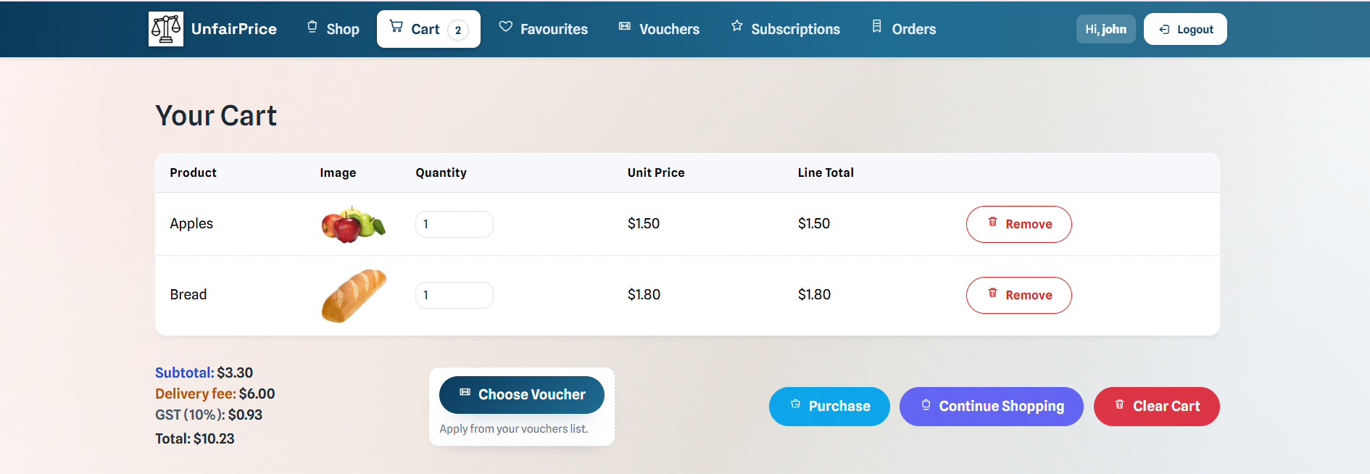
Checkout Summary
Description:
This screenshot shows the checkout page displaying the selected items, quantities, delivery method, and total payable amount. Users can review their order before proceeding to payment.
Purpose:
To confirm that the correct order details and final amount are shown before payment is initiated.

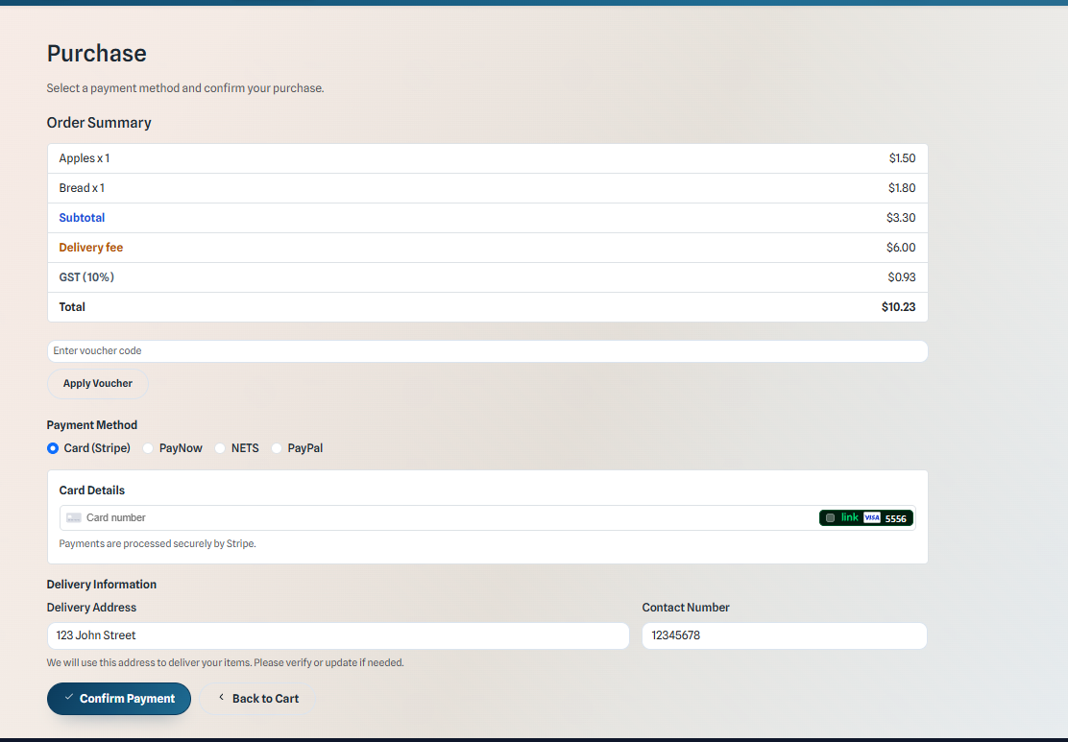
Payment Method Selection
Description:
This screenshot shows the payment method selection screen where users can choose between Stripe Card, PayNow QR, NETS QR, or PayPal Checkout.
Purpose:
To demonstrate that multiple payment options are available and selectable by the user.

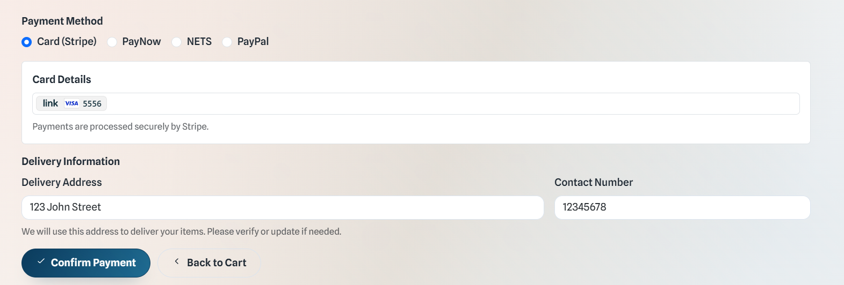

Stripe Card Payment (Card Details Entry)
Description:
This screenshot shows the Stripe card payment interface rendered using Stripe Elements, where users enter their card details securely.
Purpose:
To demonstrate secure card data entry without exposing sensitive information to the application.

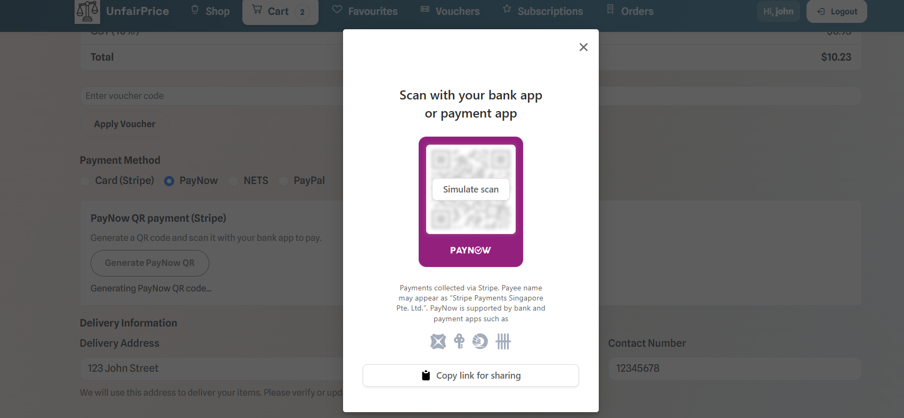
PayNow QR Code Display
Description:
This screenshot shows the QR code generated for PayNow payment, allowing the user to scan the code using their banking application.
Purpose:
To illustrate how QR-based payments are initiated within the application.

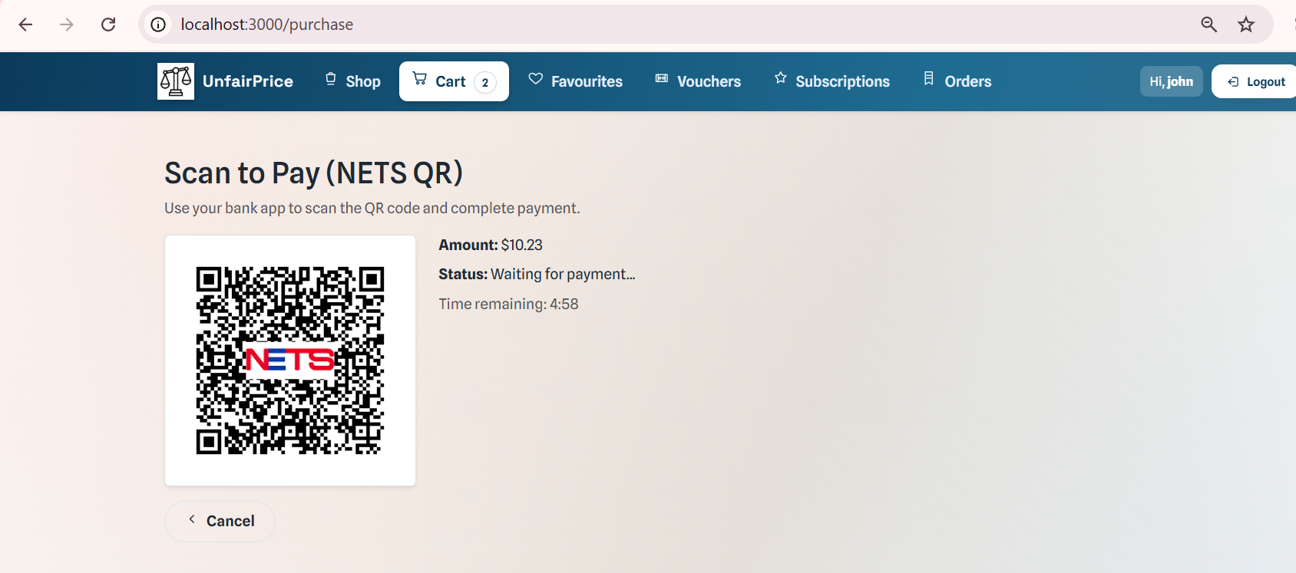

NETS QR Code Display
Description:
This screenshot shows the QR code generated for NETS payment, allowing the user to scan the code using their banking application.
Purpose:
To illustrate how QR-based payments are initiated within the application.

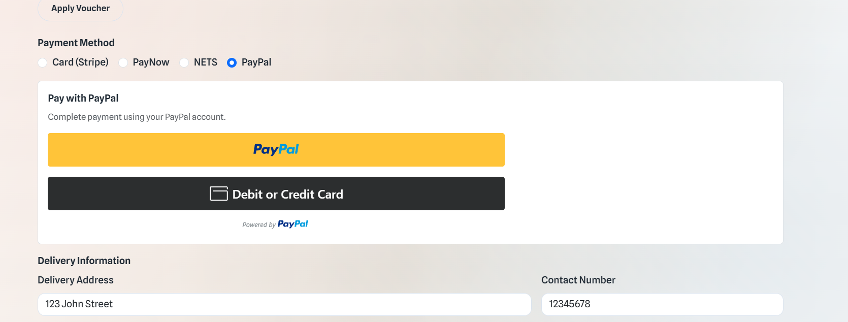

PayPal Checkout Popup
Description:
This screenshot shows the PayPal Checkout popup displayed after the user clicks the PayPal button, allowing them to log in and approve the payment.
Purpose:
To demonstrate third-party payment redirection and user approval.

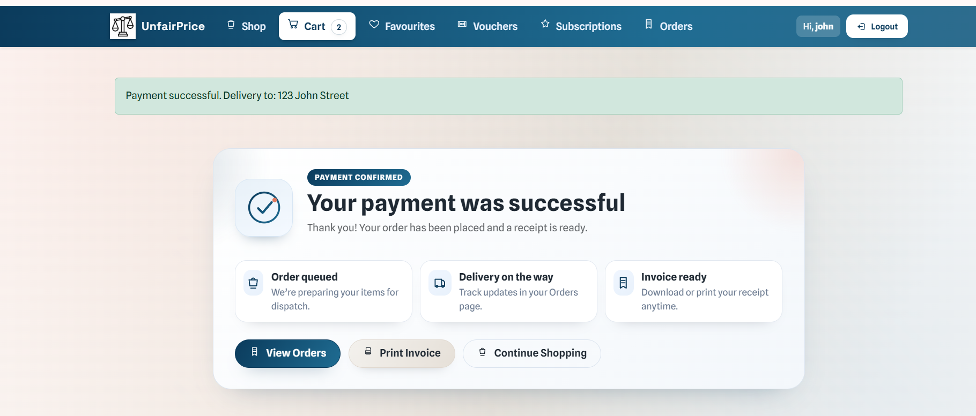
Payment Success / Order Confirmation Page
Description:
This screenshot shows the order confirmation page displayed after a successful payment. It includes order details and confirmation of payment completion.
Purpose:
To confirm that the payment has been successfully processed and the order has been created.

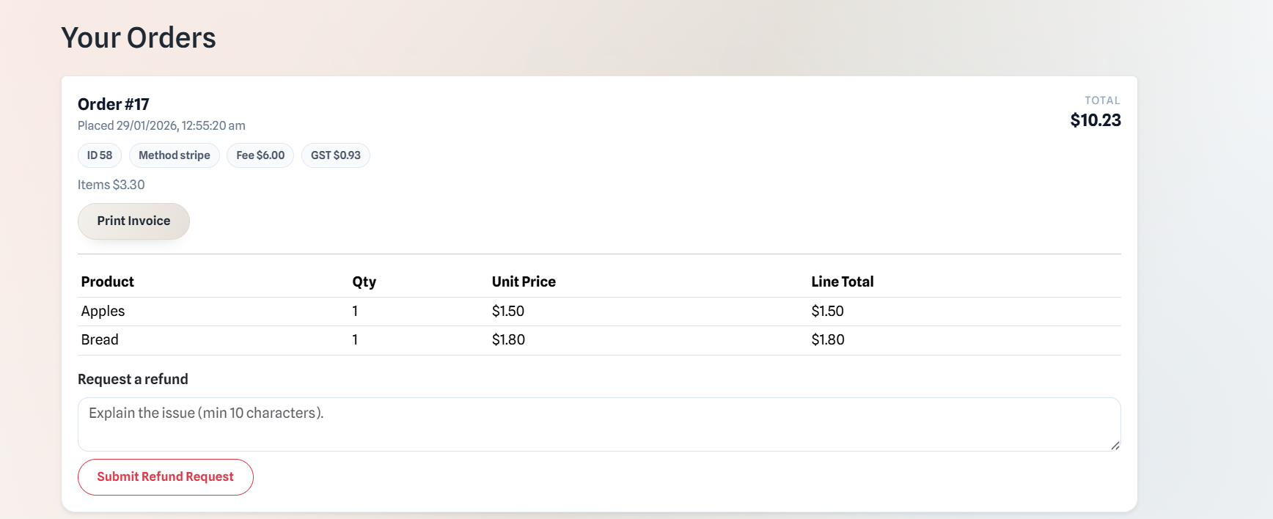
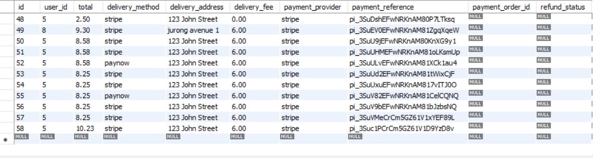
Order Record/History after Payment
Description:
This screenshot shows the corresponding order record in the database, including fields such as payment_provider, payment_reference, and payment_order_id.
Purpose:
To demonstrate that payment details are correctly recorded for tracking and audit purposes.

These screenshots collectively demonstrate the complete payment process in SupermarketAppMVC, covering user interaction, payment initiation, secure processing, confirmation, and backend record keeping.

Reflection on the use of GenAI for Enabling Payments
Focus on how you engaged with generative AI as a learning partner while implementing payment functionality.
Your responses should include specific examples from your code to demonstrate critical thinking, testing, and ethical awareness in your use of AI.

- How did you use GenAI to understand payment integration requirements?
Describe how you used AI tools to research payment solutions, clarify requirements, or explore best practices for secure payment processing. What resources or guidance did AI provide that shaped your approach?
I used GenAI to help me understand how different payment methods should be implemented in a web application. At the start, I was unsure about how Stripe, PayNow QR, NETS QR, and PayPal payments worked and what was required for each of them. GenAI helped explain the differences between these payment methods and the general payment flow, such as creating a payment, confirming payment, and only completing the order after payment is successful.

GenAI also explained best practices like handling payment logic on the server side instead of the client side and not storing sensitive payment information. This helped me better understand the existing SupermarketAppMVC code, especially how payment details such as payment_provider, payment_reference, and payment_order_id are stored in the orders table.

I also added files such as NetsDemo and StudentFinesAppPaypal as context to the AI to better understand the lesson taught and get a sense of what each components of each folder does. For stripe and paynow, I had to search it up on my own but asked AI to help me understand how the docs work and what they meant.

- What challenges did you face when enabling payments, and how did GenAI help you address them?
Reflect on any technical, security, or design challenges you encountered while implementing payments. How did you use AI to troubleshoot, generate code, or find solutions? Provide examples.
One of the main challenges I faced was understanding that each payment method has a different flow. Stripe card payments use PaymentIntent confirmation, PayNow and NETS require QR code scanning and payment status checking, while PayPal uses order creation and capture. Managing all these flows together in one application was confusing at first.

GenAI helped by breaking each payment process into simple step-by-step explanations. This made it easier for me to map each payment method to the correct controller and frontend page. GenAI also helped me understand why payment confirmation and order creation should be done on the backend to prevent users from changing payment amounts on the frontend.

- How did you ensure the payment feature was secure and reliable?
Explain how you used AI to check for security vulnerabilities, validate payment flows, or follow industry standards. Did AI help you identify potential risks or suggest improvements?.
GenAI helped me understand common security risks in payment systems, such as client-side payment manipulation and exposure of API keys. Based on this, I ensured that all payment amounts are calculated and verified on the server before completing an order.

I also learned that API keys should be stored in environment variables instead of hardcoding them in the source code. Payment details such as card numbers are not stored in the database, and only payment references returned by the payment providers are saved. These practices helped make the payment feature more secure and reliable.

I kept asking the AI to check to make sure that the payment logic flows and if add logs to ensure that everything in the payment part went smoothly.

- How did you test and validate the payment functionality with the help of GenAI?
Describe your process for testing the payment feature. Did you use AI to generate test cases, debug errors, or verify that transactions were processed correctly? What changes did you make based on AI feedback?
GenAI helped me come up with test cases to check whether the payment system was working correctly. These included successful payments, failed payments, and pending payment scenarios, especially for QR-based payments like PayNow and NETS.

Using these suggestions, I tested all payment methods using sandbox environments provided by Stripe, NETS, and PayPal. After each test, I checked the database to ensure that the order and payment information was stored correctly. This helped me confirm that the payment flows worked as intended. I also checked the respective sandbox accounts and dashboard to ensure that the payment did in fact flow through and the amount of products bought from my app matches the transaction amount shown in the sandboxes.
Postman .env (environment variables) is a way to store reusable values in Postman so you don’t hard-code them into every API request. It allows you to define variables like:
- API base URLs
- Access tokens
- Client IDs / secrets
- Keys that change between sandbox and production

By using that, I was able to test some of my APIs instead of tying them again and again, making my time more efficient.

- What limitations or risks did you notice in the AI’s suggestions for payment integration?
Critically evaluate the AI’s responses. Did it ever suggest insecure, outdated, or non-compliant solutions? How did you identify and address these issues?
Sometimes, GenAI gave very general suggestions that did not fully match the structure of SupermarketAppMVC. For example, it suggested alternative approaches or tools that were not used in the project.

To handle this, I did not blindly follow all AI suggestions. I compared them with the existing codebase and official documentation from Stripe, NETS, and PayPal. Only suggestions that matched the project structure and best practices were used.

GenAI also tends to add audit and error logs that tend to go around in circles and never truly fixing the problem. Thus, you still must manually troubleshoot and debug the code sometimes as it can be unreliable in that sense.

I also used docs from each API and read them thoroughly to understand how each API worked so that in the event that the AI faced an error while integrating, I could refer back to the docs and manually fix it.

- How did you balance AI assistance with your own learning and decision-making?
Discuss how you ensured that using AI enhanced your understanding of payment systems, rather than just providing answers. What steps did you take to independently review, test, or adapt AI-generated solutions?
I used GenAI as a guide to help me understand payment concepts instead of copying solutions directly. After receiving explanations from GenAI, I reviewed the code, tested the payment flows, and checked the database updates myself.

By doing this, I was able to learn how payment systems work while still making my own decisions. GenAI helped me learn faster, but the final implementation and testing were done by me, which improved my understanding of payment systems overall.

GenAI guided me throughout the entire project, feeding me information and helping me solve my problems while also allowing me to code and make my own decisions on how the app should be, not restricting me.

